**Setup Your Raspberry Pi**

1. **Prepare the SD card**
   1. Make sure the SD card is completely empty. Format the SD card if it is used previously.
   2. Download NOOBS to the SD card (<https://www.raspberrypi.org/downloads/noobs/>)  
      NOOBS is an installer for Raspbian, the operating system which works with Raspberry Pi. Unzip the file and copy all the files to the SD card.
   3. Insert the SD card into the Raspberry Pi.
2. **Install Raspbian**
   1. Connect the USB keyboard, USB mouse and USB Wifi Adapter to the Raspberry Pi. Connect the HDMI-to-VGA adapter to the Raspberry Pi, and connect it to the monitor using the VGA cable.
   2. Start the Raspberry Pi by connecting it to the power adapter.
   3. The setup page will be loaded. Check the box next to “Raspbian” and click “Install (i)” on the top.  
      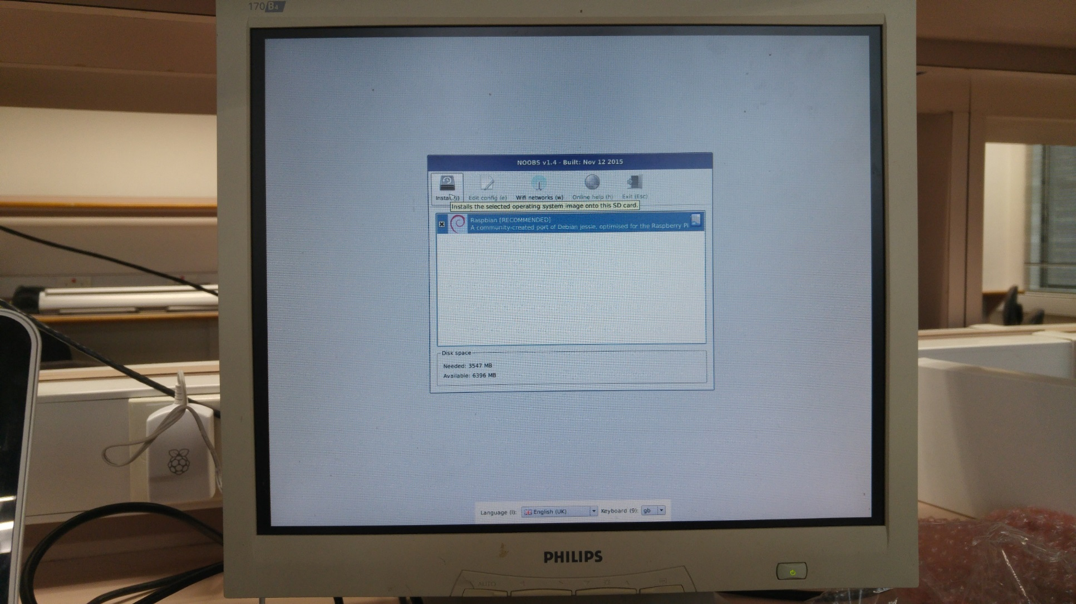
   4. A warning will pop up to warn you that existing data on the SD card will be overwritten. Click “Yes” to continue.
   5. Wait until the installation complete.
   6. A pop up message showing that “OS(es) Installed Successfully”. Click “OK” and the Raspberry Pi would restart itself.
   7. After reboot, the GUI of Raspbian would be loaded.  
       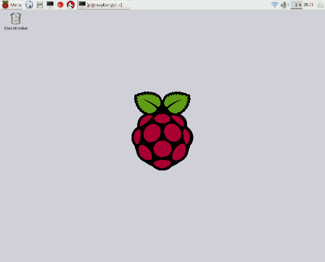
3. **Setup Wifi Connection (with GUI)**
   1. Find the internet connection logo (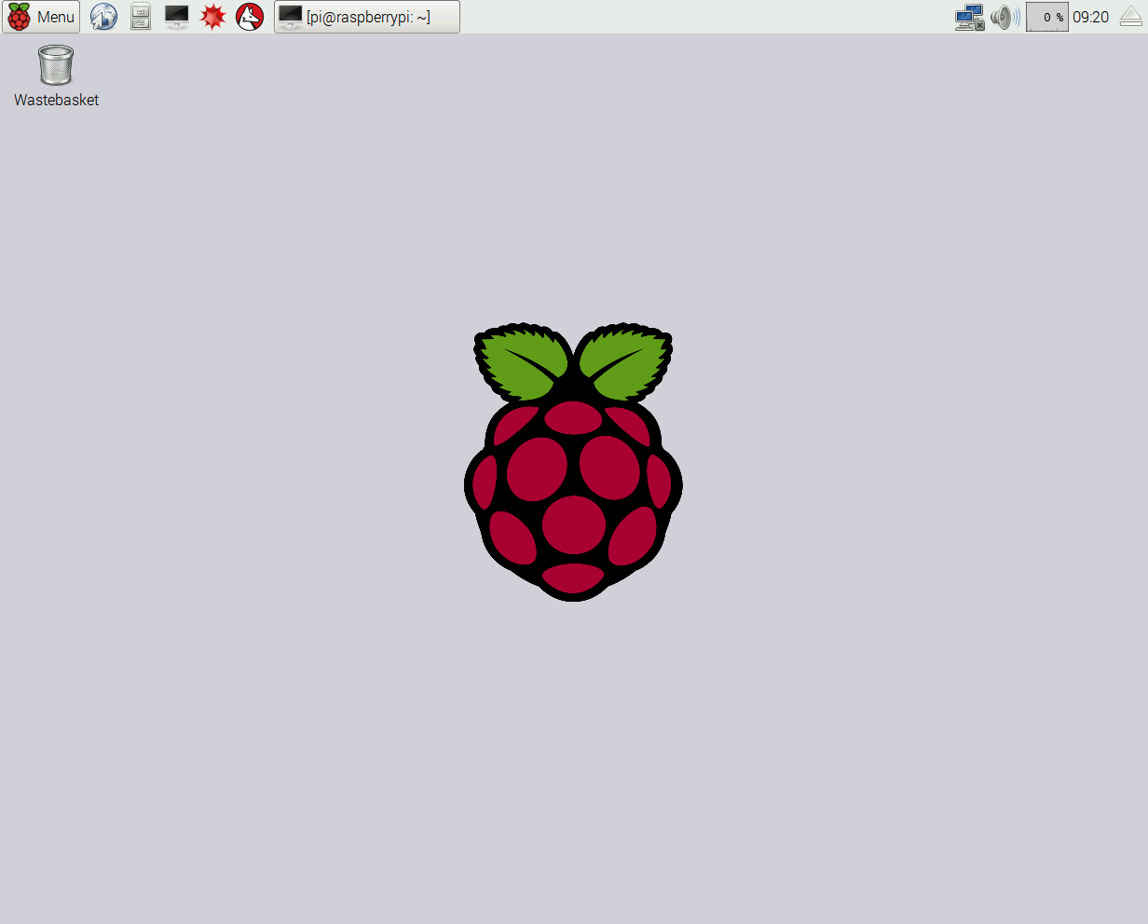) on the top right corner. Click on the logo and a list of nearby AP would be shown.  
       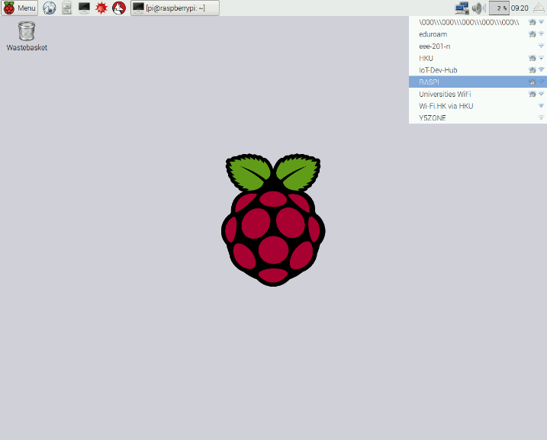
   2. Select the AP to be connected, and enter the key in the popup window. 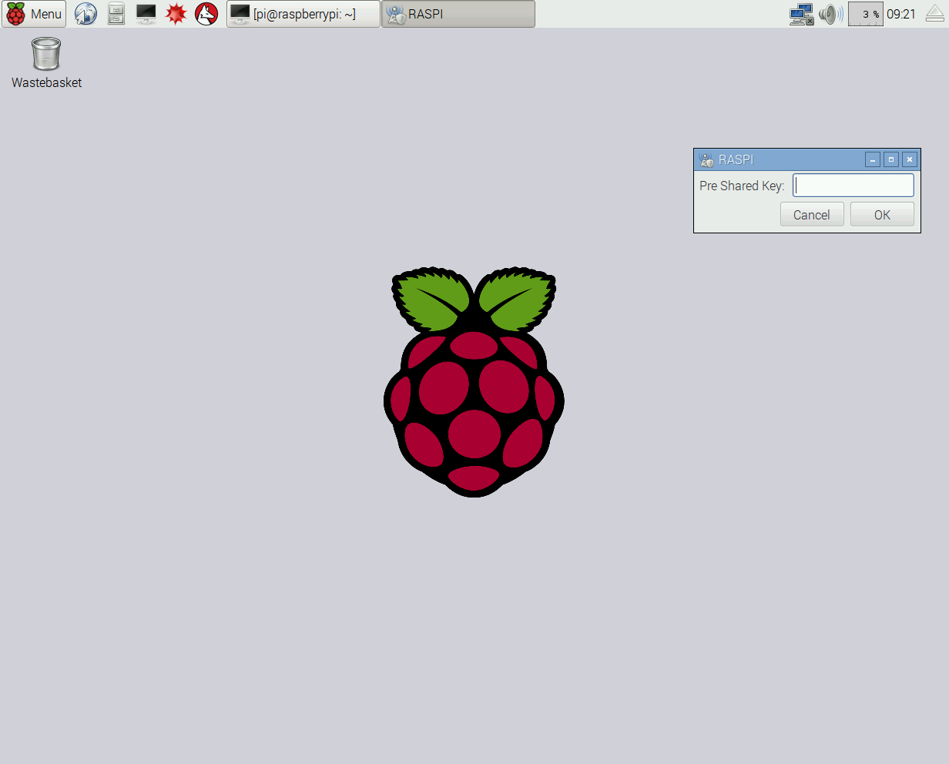
   3. Once the Wifi logo appears (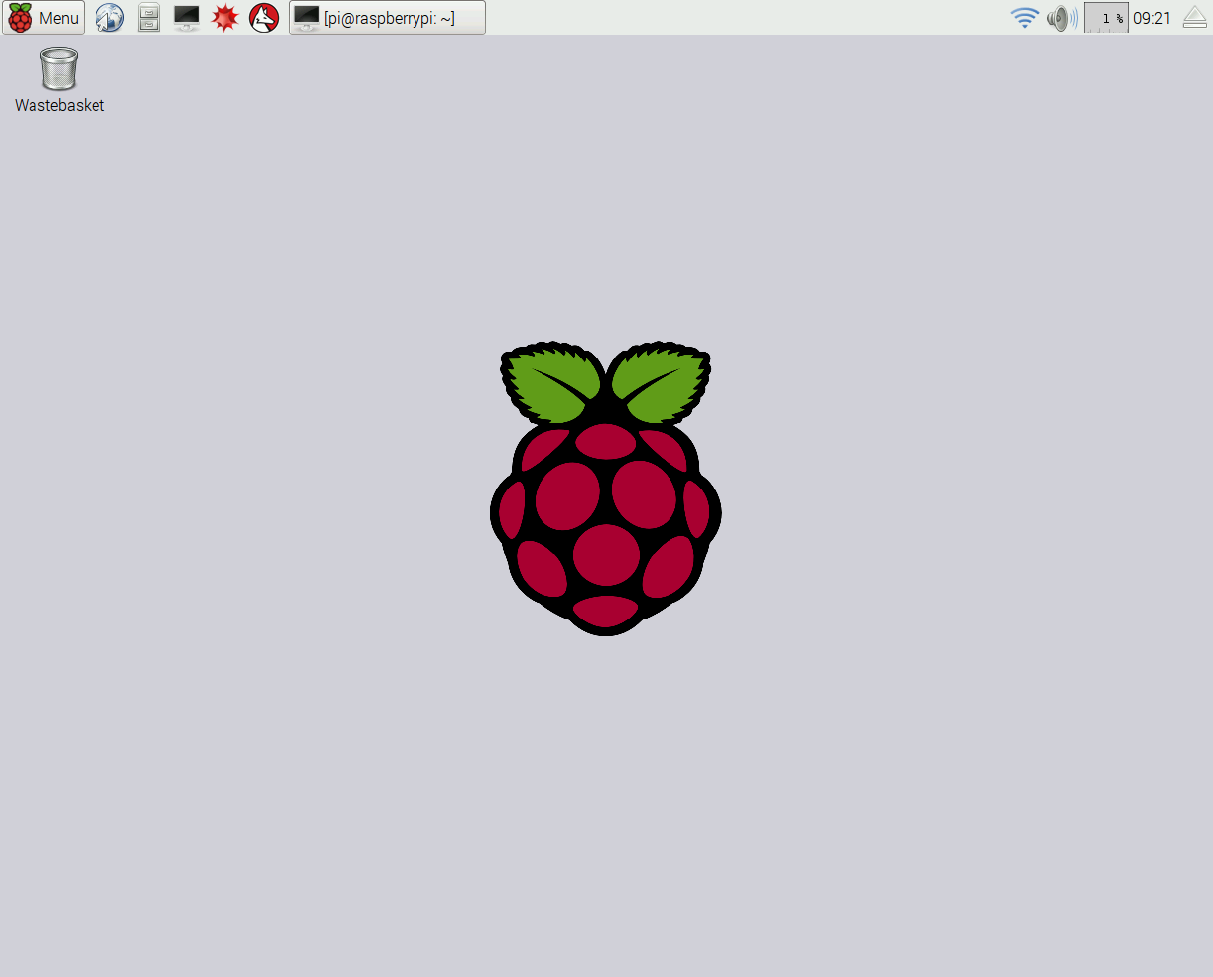), the connection is established and the Raspberry Pi is connected to the internet.
   4. Hover the mouse on the logo to see the IP address allocated to the Raspberry Pi.  
      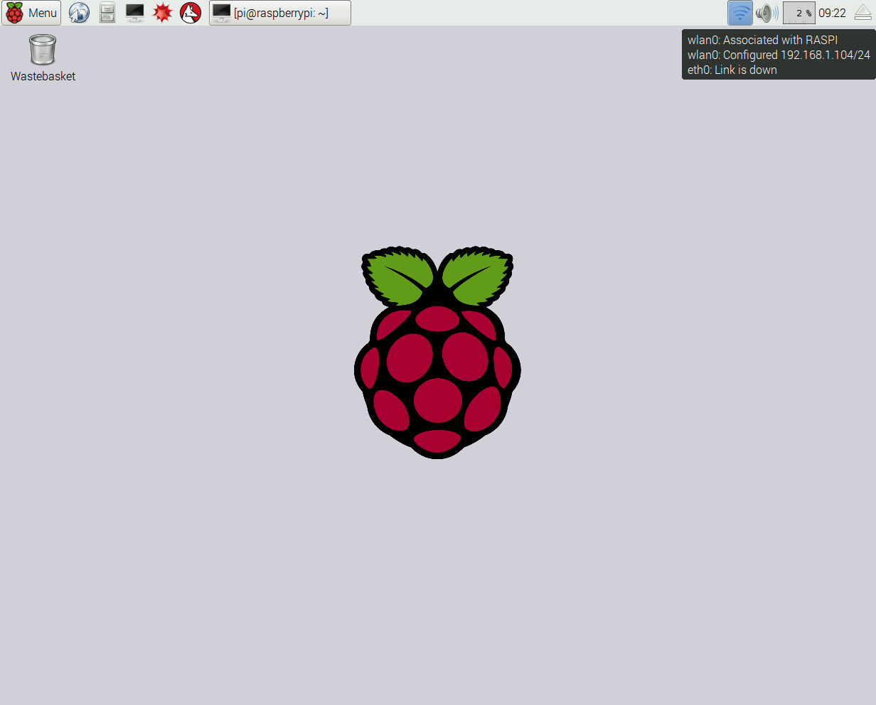
4. **Setup Wifi Connection (with command line)**
   1. Without the GUI, the Raspberry Pi can still be configured to connect to wireless AP. To scan the nearby AP available, use the command:

|  |
| --- |
| sudo iwlist wlan0 scan |

* 1. To add a known AP, open the wpa-supplicant configuration file with the command

|  |
| --- |
| sudo nano /etc/wpa_supplicant/wpa_supplicant.conf |

* 1. At the bottom of the file add the following:

|  |
| --- |
| network = {  ssid = "*SSID_of_wireless_AP* "  psk = "*AP_password* "  } |

where the value for ssid is the name of the AP to be connected and the value of psk is the key for the AP.

* 1. Save the file by pressing **Ctrl + X** then **Y**, then **Enter**.
  2. Normally, wpa-supplicant would notice the change of the configuration file and connect to the network automatically. Check the connection with the command

|  |
| --- |
| ifconfig wlan0 |

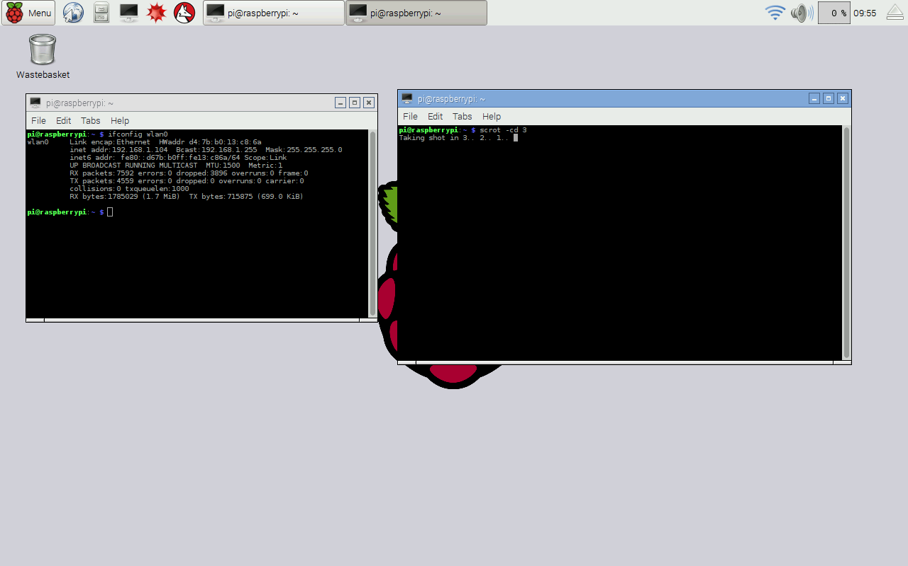

If it does not connect to the wireless AP, try to manually restart the wireless by using

|  |
| --- |
| sudo ifdown wlan0  sudo ifup wlan0 |

or simply restart the Raspberry Pi by

|  |
| --- |
| sudo restart |

1. **Set up Ethernet connection between Raspberry Pi and PC (Windows)**
   1. Without the Wifi connection, a PC can still connect to the Raspberry Pi by direct connection via Ethernet cable. Connect the Ethernet cable to both Ethernet ports of Raspberry Pi and PC.
   2. To allow the Raspberry Pi to go to the internet through the PC, the internet connection via Wifi should be shared with other network. Go to Control Panel > Network and Internet > Network and Sharing Center, click on 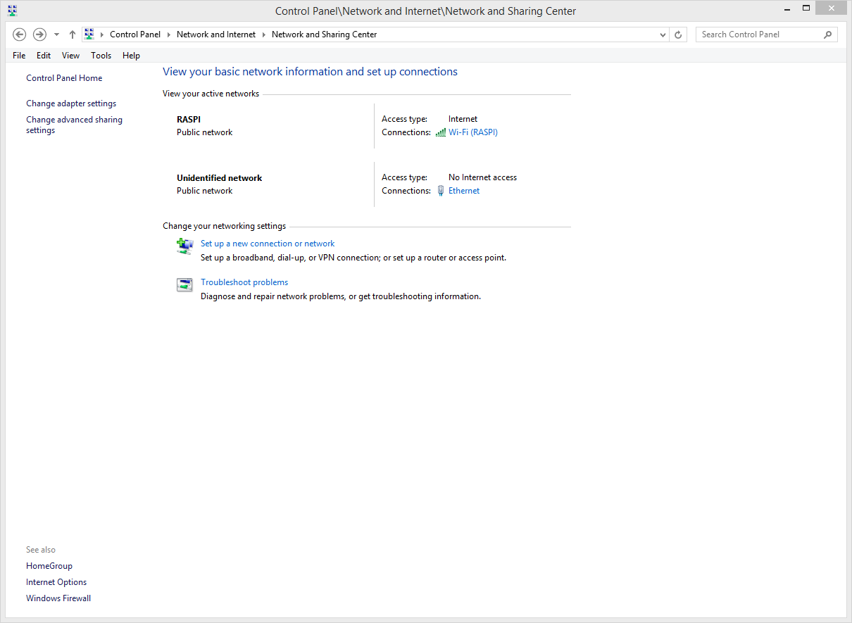 to see “Wi-Fi Status”.
   3. Click on “Properties”, and visit the tab “Sharing”. Check the box “Allow other network users to connect through this computer’s Internet connection. Select the Ethernet network if needed to. Click “OK” to save the setting.  
      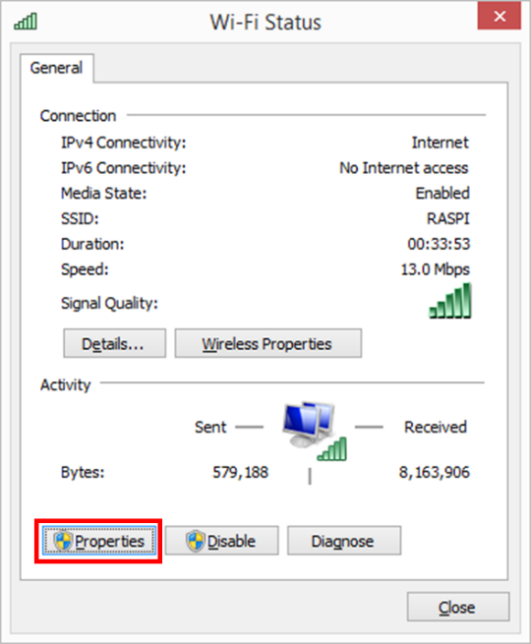 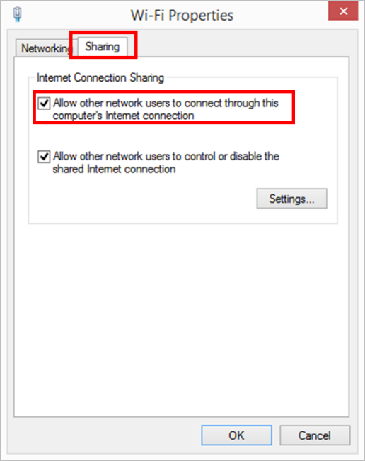
   4. Back to Network and Sharing Center, click on  to see Ethernet Status. Click on “Details…” to see the current IP of your PC on Ethernet (it should be 192.168.137.x).

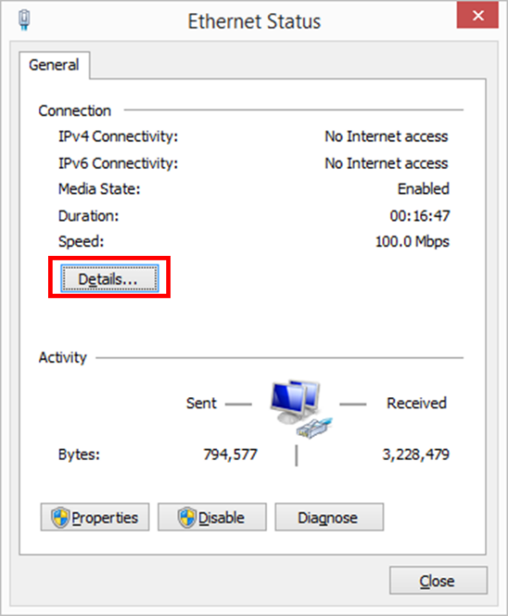 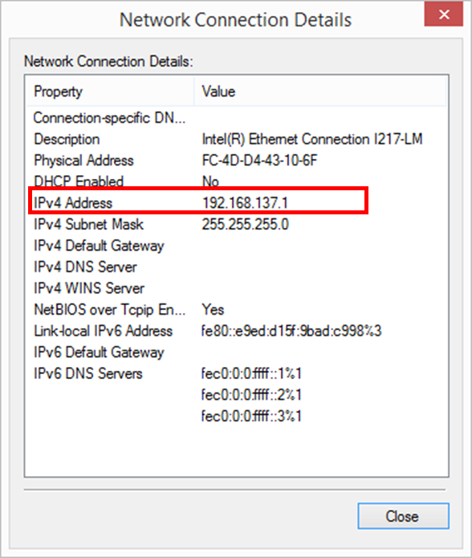

* 1. To know the IP address of your Raspberry Pi, open the Command Prompt (cmd.exe) on your PC. Try to send broadcast ping on Ethernet network by

|  |
| --- |
| ping 192.168.137.255 |

(If the network shown in the Ethernet detail is different, replace the corresponding IP address with your Ethernet IP network broadcast address.)

It is expected that you will see “Request timed out” as output and all the Ping Packets are lost, as Raspberry Pi would not answer broadcast ping by default for security reason.

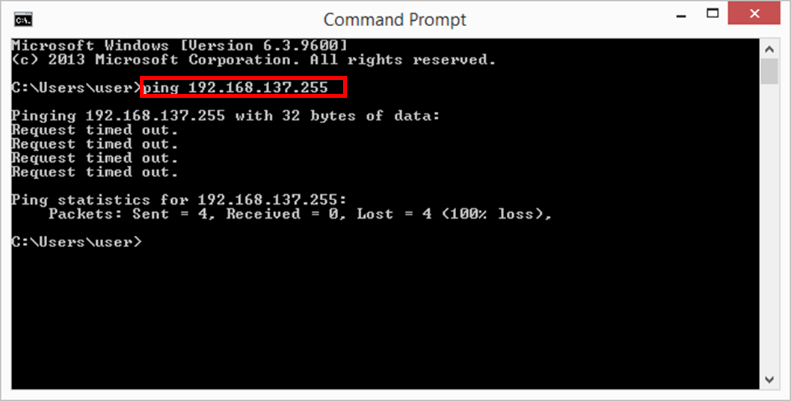

* 1. Type the following command

|  |
| --- |
| arp –a |

* 1. And look for the IP address of Raspberry Pi under your Ethernet network (which by default is 192.168.137.x). The physical address of Raspberry Pi should be “b8-27-eb-xx-xx-xx”, and the Type of the address should be “dynamic”. 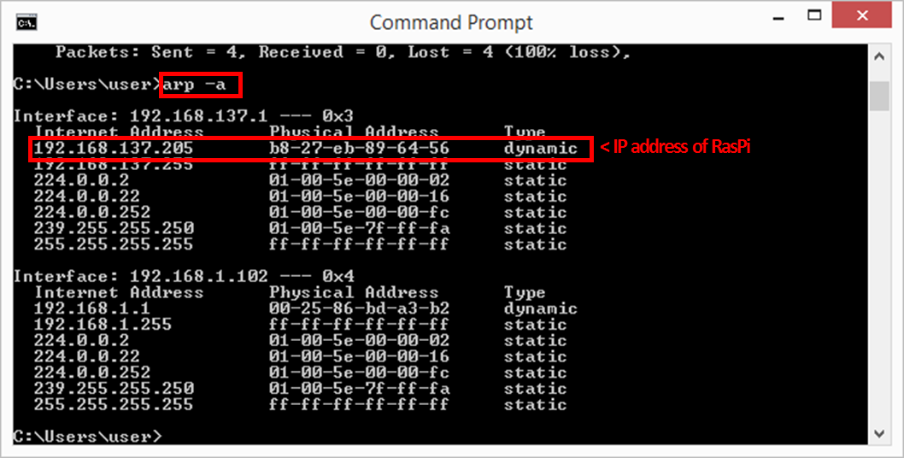

Thus you can connect to your Pi with SSH or VNC using the IP obtained.

* 1. Remember to cancel the network sharing in step 5.3 after the use of Raspberry Pi.

1. **Allow SSH connection to Raspberry Pi**
   1. To access to the Raspberry Pi without the need of external monitor, it would be a good idea to allow SSH connection to it. To do so, use the command in a console:

|  |
| --- |
| sudo raspi-config |

* 1. A menu for configuration would be shown. Using the arrow keys, select  
     “9 Advance Options” >> “A4 SSH”

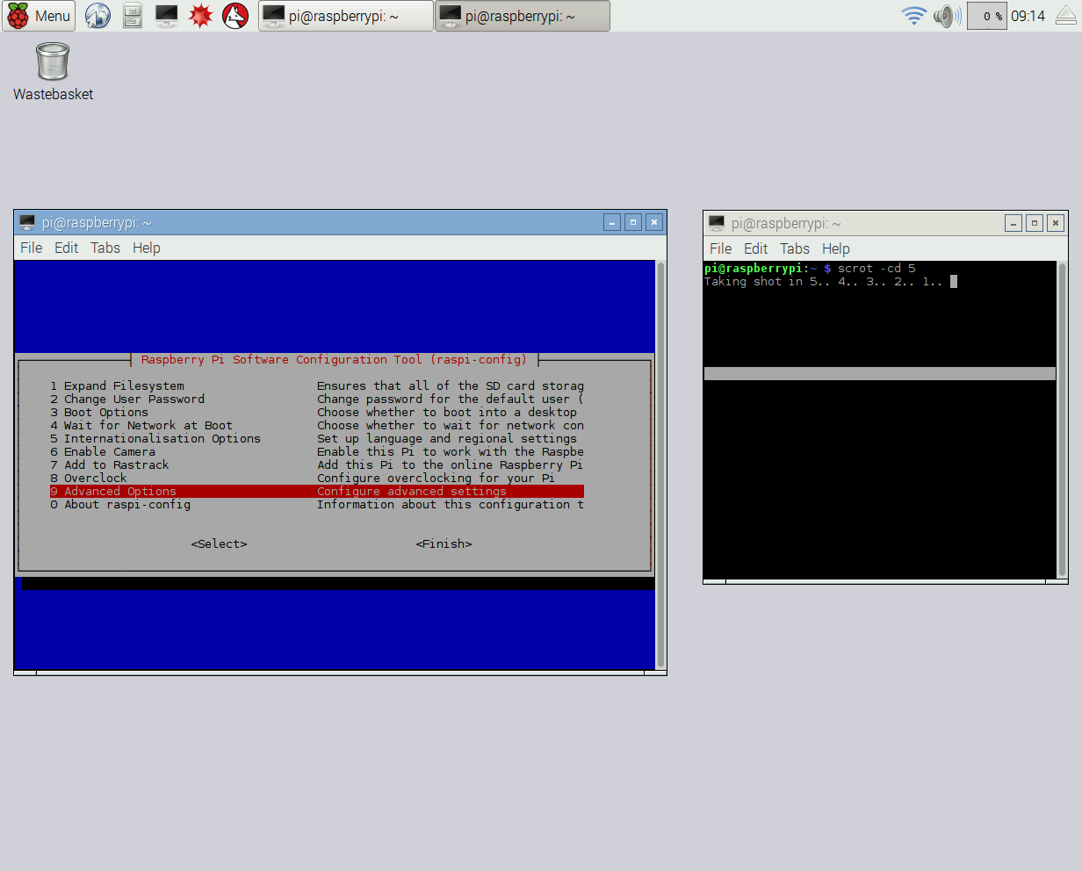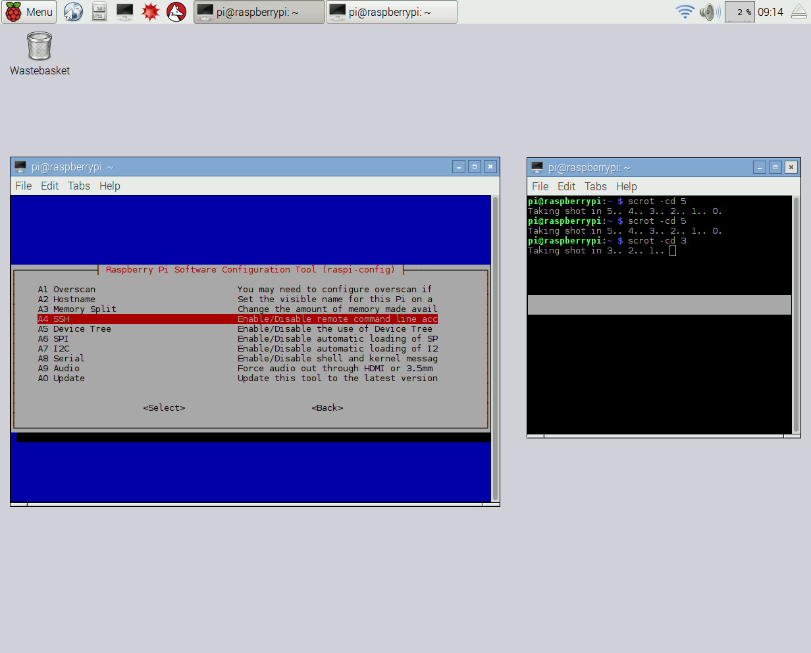

* 1. Select “Enable” to make the SSH server enabled on the Raspberry Pi.

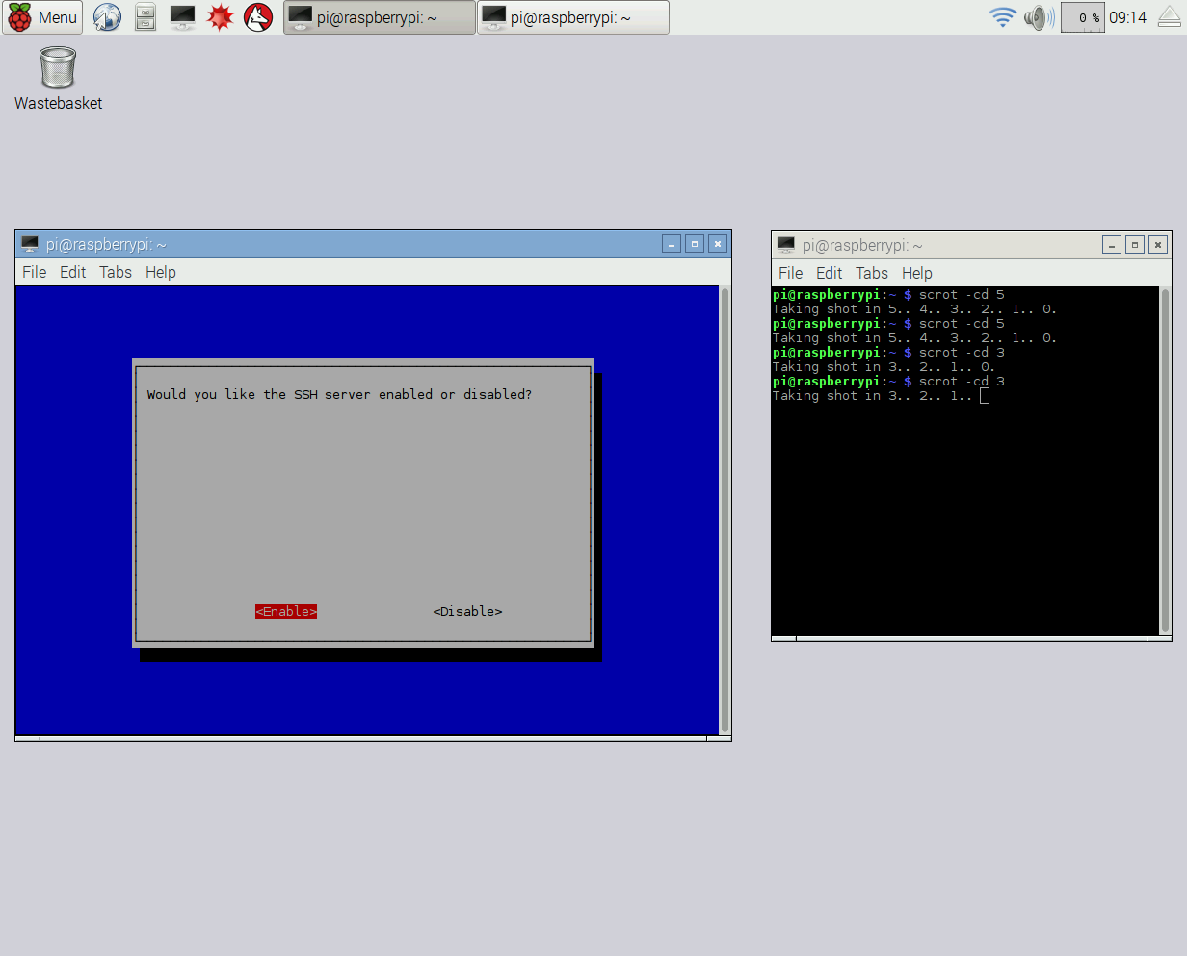

* 1. A message showing “SSH server enabled”. Press enter to exit from the menu. Select “Finish” to exit from raspi-config.

1. **Connect to Raspberry Pi via SSH using putty (Windows)**
   1. To access the Raspberry Pi via SSH, we can use a free SSH client called “PuTTY”. Download and run the execution file for “PuTTY”. (<http://the.earth.li/~sgtatham/putty/latest/x86/putty.exe>)
   2. Input the IP address of the Raspberry Pi. The Port for the connection should be 22, and connection type is SSH. To save your time to input the information every time, you can save the session information to “Default Settings”. Click “Open” to initiate the SSH connection.

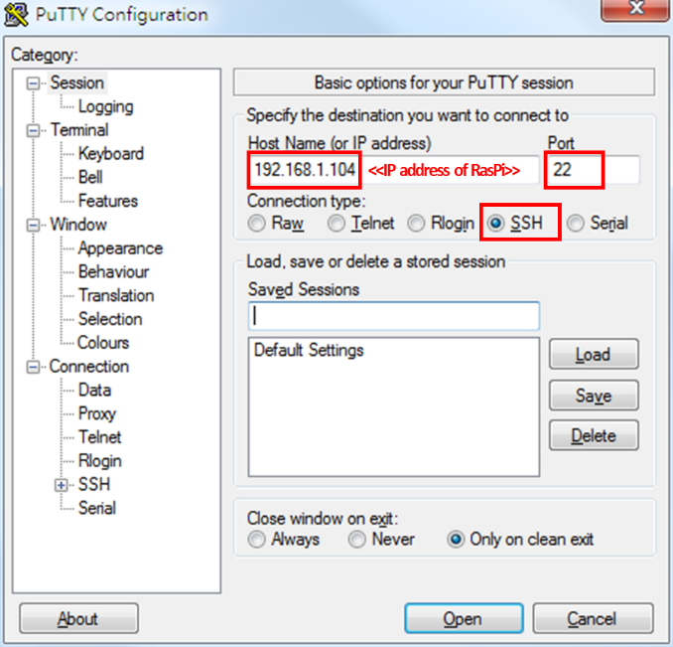

* 1. A console will appears for the SSH connection. After establishing the connection, it will require you to login. Enter your username on Raspberry Pi (default is “pi”) and press enter. Then enter the corresponding password (default is “raspberry”) and press enter to login. Characters of password would not be shown for security reason.

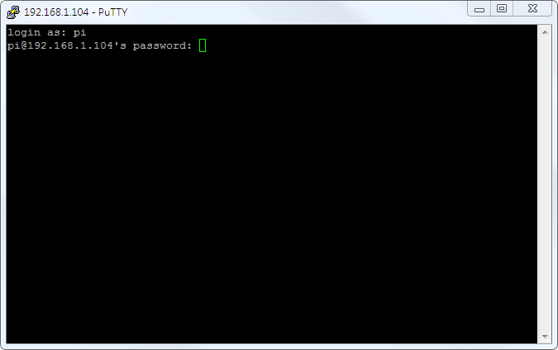

* 1. After successful login, you will see some welcoming message and

|  |
| --- |
| ***<your username>***@raspberrypi: ~ $ |

Then you can control the Raspberry Pi just like using the console on it.

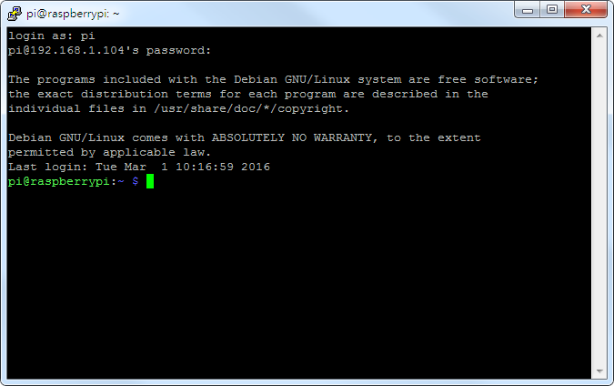

1. **Setup VNC Server on Raspberry Pi**
   1. VNC is a graphical desktop sharing system that allows users to remotely control one computer from another. By setting up a VNC server on Raspberry Pi, you can access the graphical user interface of the Raspberry Pi without an external monitor. On the Raspberry Pi (or via SSH connection) console, install the TightVNC package with

|  |
| --- |
| sudo apt-get install tightvncserver |

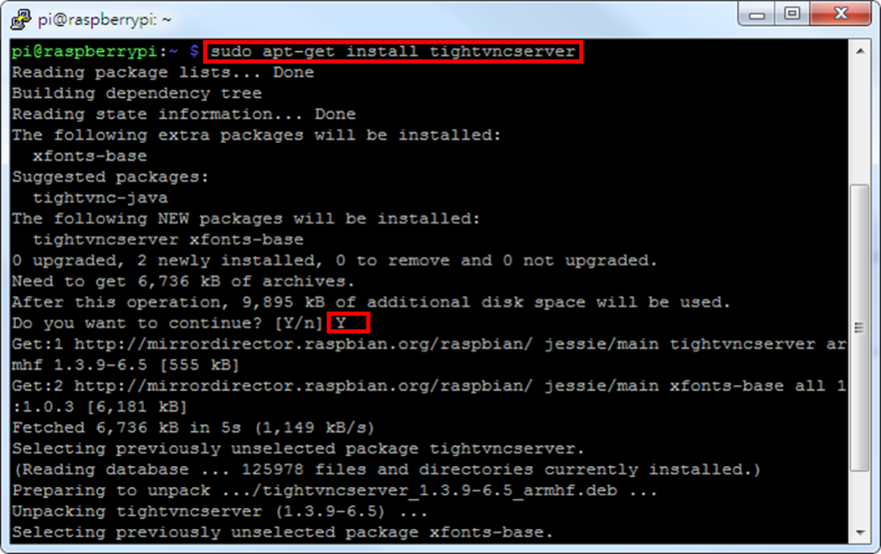

* 1. Then, run TightVNC server to setup a password for remote control connection and an optional view-only password.

|  |
| --- |
| tightvncserver |

Enter a password with 8 characters. You can input a longer password but it will be truncated. There is no need to setup a view-only password. A new desktop numbered as 1 would be created.

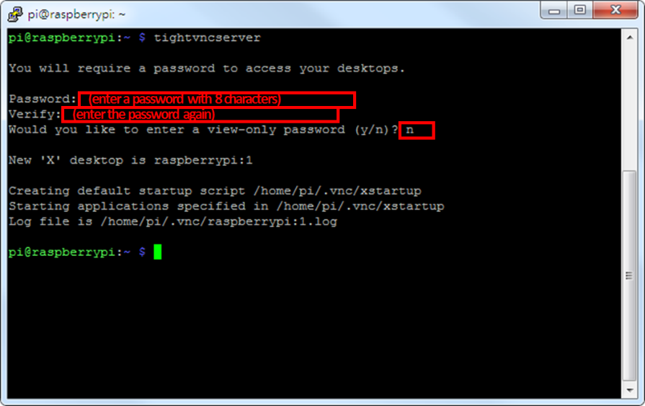

* 1. (Optional) If you prefer your mouse pointer in the VNC client appears as arrow instead of an “x”, edit the configuration file by

|  |
| --- |
| nano ~/.vnc/startup |

Add the following parameter to the line begins with “xsetroot”

|  |
| --- |
| -cursor_name left_ptr |

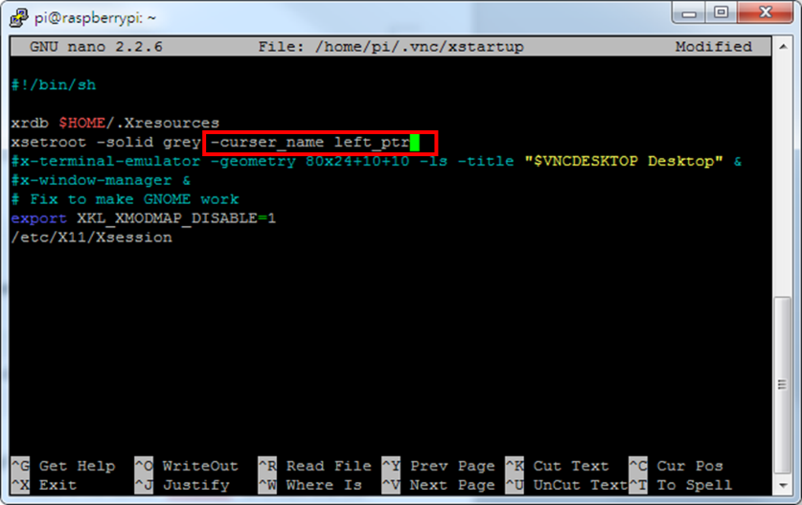

Press **Ctrl+X**, **Y** then **Enter** to save and exit.

* 1. To make the VNC server run at boot, log into a terminal on the Raspberry Pi as root and navigate to the directory “/etc/init.d/”. Create a file called “vncboot” and edit the file with nano:

|  |
| --- |
| sudo su  cd /etc/init.d/  touch vncboot  nano vncboot |

* 1. Enter the following script into the file, press **Ctrl+X**, **Y** then **Enter** to save and exit.

|  |
| --- |
| #! /bin/sh  # /etc/init.d/vncboot  ### BEGIN INIT INFO  # Provides: vncboot  # Required-Start: $remote_fs $syslog  # Required-Stop: $remote_fs $syslog  # Default-Start: 2 3 4 5  # Default-Stop: 0 1 6  # Short-Description: Start VNC Server at boot time  # Description: Start VNC Server at boot time.  ### END INIT INFO  USER=pi  HOME=/home/pi  export USER HOME  case "$1" in  start)  echo "Starting VNC Server"  #Insert your favoured settings for a VNC session  su - $USER -c "/usr/bin/vncserver :1 -geometry 1280x800 -depth 16 -pixelformat rgb565"  ;;  stop)  echo "Stopping VNC Server"  /usr/bin/vncserver -kill :1  ;;  *)  echo "Usage: /etc/init.d/vncboot {start|stop}"  exit 1  ;;  esac  exit 0 |

* 1. Make this file executable by

|  |
| --- |
| chmod 755 vncboot |

* 1. Enable dependency-based boot sequencing

|  |
| --- |
| update-rc.d vncboot defaults |

* 1. (Optional) To save memory, we can disable the displaymanager running on :0 at boot (i.e. the X session which is shown on the external monitor). By doing so, you will not see any GUI from the HDMI output.

|  |
| --- |
| update-rc.d lightdm remove |

If you want to enable the displaymanager at boot again, execute the following

|  |
| --- |
| update-rc.d lightdm defaults |

* 1. Reboot the Raspberry Pi and VNC server would be started at boot.

|  |
| --- |
| reboot |

1. **Connect to Raspberry Pi over VNC (Windows)**
   1. Download and install a VNC client program e.g. TightVNC (<http://www.tightvnc.com/download.php>). You are only required to install the TightVNC Viewer, other components are optional.
   2. After installation, you will find “TightVNC Viewer” in the start menu. Run it and a dialog would appear. Enter the IP address of the Raspberry Pi, followed by the screen number (by default “:1”), e.g. “192.168.1.104:1”.

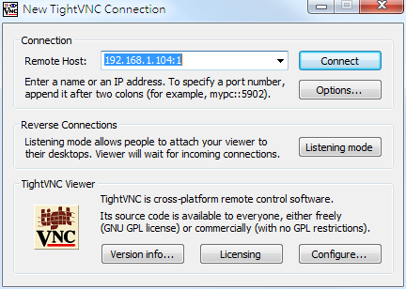

* 1. Enter the password you set during the setup of VNC server on Raspberry Pi in the prompt.

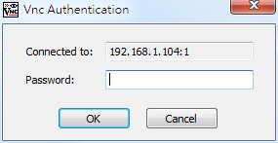

* 1. After connection, you can control the Raspberry Pi on your PC just like doing that directly with mouse and keyboard.

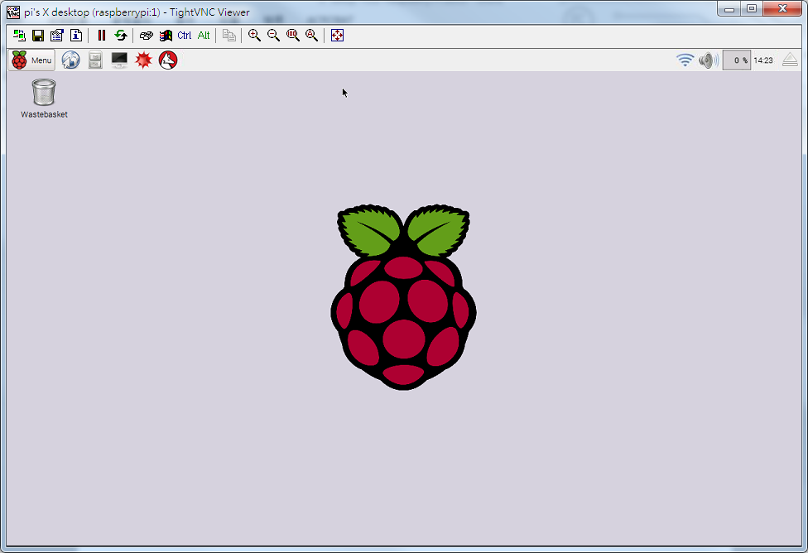

1. **File Transfer between Raspberry Pi and PC using FileZilla**
   1. File transfer between Raspberry Pi and PC can be done easily by FileZilla. Download and install the latest FileZilla Client (<https://filezilla-project.org/download.php?type=client>).
   2. After execution, you will see the window for file transfer. Enter the IP address of your Pi in the field “host”; and also your username (default is “pi”) and password (default is “raspberry”). The port for the connection would be 22.

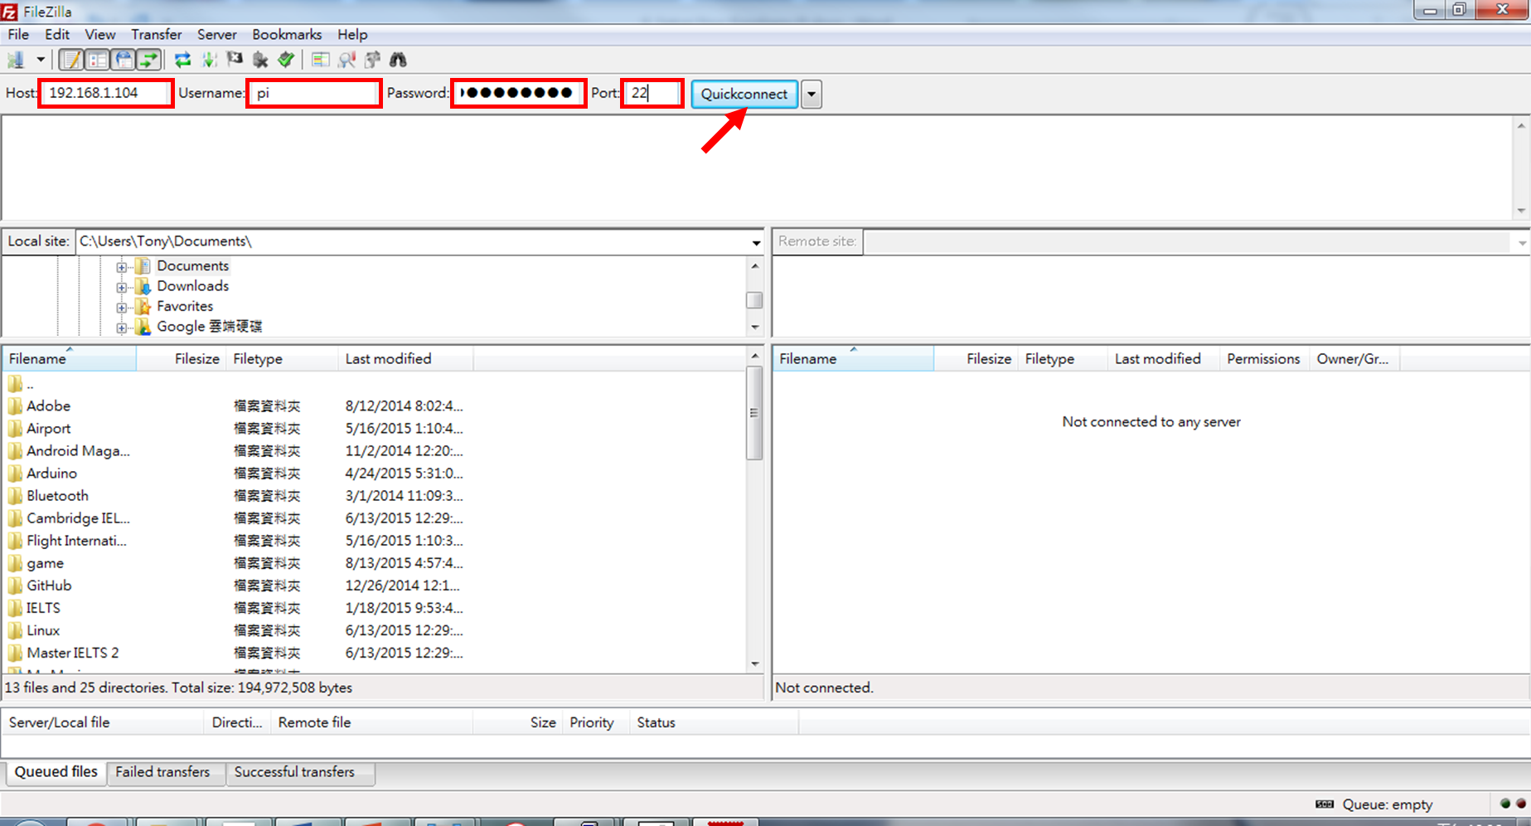

Click “Quickconnect” to connect to the Raspberry pi.

* 1. The files on the left are the local files on your PC and the files on the right are the remote files on the Raspberry Pi. Transfer the required files by simply drag and drop between left and right.

